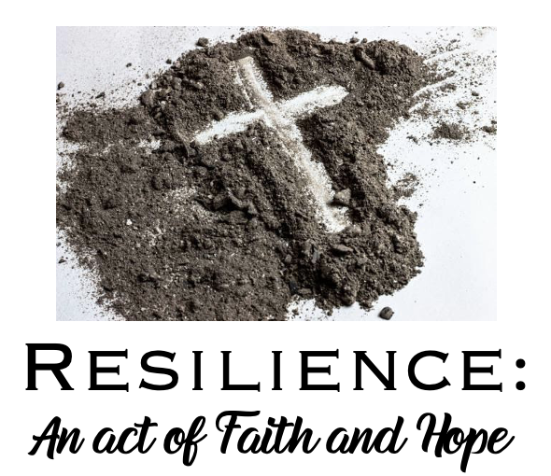
_____________________________________________________________________________
The suffering won't last forever. It won't be long before this generous God
who has great plans for us in Christ - eternal and glorious plans they are!
– will have you put together and on your feet for good.
1st Peter 5:10 - The Message Bible
Prelude

Invitation to Worship
Gather us in, O Lord, as your people; people who are grounded in faith and who understand resilience as a gift that is seen in Expecting; Knowing; Trusting; Resisting; Believing and Living.
Hymn – ELW #532 Gather Us In (vs. 4)
Not in the dark of buildings confining, not in some heaven, light years away—
Here in this place the new light is shining, now is the kingdom, and now is the day.
Gather us in and hold us forever, gather us in and make us your own;
Gather us in, all peoples together, fire of love in our flesh and our bone.

Centering Litany – God is in Us by Susan Palo Cherwein
Perhaps we do not remember it,... as loving arms held us
and water of new belonging splashed over us.
Each Ash Wednesday we see the sign again revealed.
We had forgotten it on ourselves;
we had neglected to see it on others,
But it persists.
That sign.
That cross.
A smudge of mortality.
A nudge of remembrance.
A remembrance of water poured.
A remembrance of anointing.
A remembrance of a way made straight for God.
You have been sealed… (point to your heart)
With the cross… (make the sign of the cross on your forehead)
Forever. Forever.
And the glory of the Lord shall be revealed. AMEN.

The Word – Scripture, Sermon & Song
Feb 24 – Pr. Meg Hoversten | Resilience is Expecting God to Always Be Faithful
Text: Luke 1:22-37
Song: ELW #808 Lord Jesus, You Shall Be My Song

March 3 – Pr. Dawn Lindberg | Resilience is Knowing You Don’t Have to Go It Alone
Text: Ruth 1:1–18
Song: ELW #325 I Want Jesus to Walk with Me

March 10 – Pr. Amanda Schultz Garcia | Resilience is Trusting That God is Present in Suffering
Text: Luke 13:11-13
Song: ELW #611 I Heard the Voice of Jesus Say

March 17 – Pr. Gloria Stubitsch | Resilience is Resisting with Courage
Text: Exodus 1:15-21
Song: ELW #326 Bless Now O God the Journey

March 24 – Pr. Julie Wollman | Resilience is Believing That God’s Grace is Enough
Text: Genesis 50:15-21
Song: ELW #733 Great Is Thy Faithfulness

Prayers – Watch, O Lord by Marty Haugen
Lord’s Prayer
Blessing – paraphrased from 1st Peter
Beloved, this suffering won't last forever. Our generous God has great plans for us in Christ. Our God will strengthen within us what is needed to go forth in confidence and with resilience, to share the good news and to act for justice in the world, in the name of God the creator, sustainer and redeemer. Amen.
Gather Us In. © 1982, GIA Publications, Inc. Watch, O Lord. © 2003, GIA Publications, Inc. Text: Adapt from a prayer of St. Augustine; © 2003, GIA Publications, Inc. All rights reserved. ONE LICENSE, License #734442-A. God is in Us by Susan Palo Cherwien. Meditations for Worship © 2003 MorningStar Music Publishers, St. Louis.
The suffering won't last forever. It won't be long before this generous God who has great plans for us in Christ - eternal and glorious plans they are! - will have you put together and on your feet for good. (1st Peter 5:10 - The Message Bible)
Prelude

Invitation to Worship
Welcome to Worship. I am...
We welcome you to light a candle as we gather for this time of worship.
As we share in our opening litany, be ready to point to your chest and then make the sign of the cross. Now let us prepare our hearts and minds for worship.
Gather us in, O Lord, as your people; people who are grounded in faith and who understand resilience as a gift that is seen in Expecting; Knowing; Trusting; Resisting; Believing and Living.
Hymn: Gather Us In #532 (vs. 4)
Not in the dark of buildings confining, not in some heaven, light years away—
Here in this place the new light is shining, now is the kingdom, and now is the day.
Gather us in and hold us forever, gather us in and make us your own;
Gather us in, all peoples together, fire of love in our flesh and our bone.

Centering Litany
We are reminded that centering on Christ we are resilient – hear these words and the assurance that God is with us; God is in us:

GOD IS IN US by Susan Palo Cherwien

Perhaps we do not remember it,... as loving arms held us
and water of new belonging splashed over us.
Each Ash Wednesday we see the sign again revealed.
We had forgotten it on ourselves;
we had neglected to see it on others,
But it persists.
That sign.
That cross.
A smudge of mortality.
A nudge of remembrance.
A remembrance of water poured.
A remembrance of anointing.
A remembrance of a way made straight for God.
You have been sealed… (point to your heart)
With the cross… (make the sign of the cross on your forehead)
Forever. Forever.
And the glory of the Lord shall be revealed. AMEN.

The Word – Scripture, Sermon & Song
Feb 24 – Pr. Meg Hoversten | Resilience is Expecting God to Always Be Faithful
Text: Luke 1:22-37
Song: ELW #808 Lord Jesus, You Shall Be My Song

March 3 – Pr. Dawn Lindberg | Resilience is Knowing You Don’t Have to Go It Alone
Text: Ruth 1:1–18
Song: ELW #325 I Want Jesus to Walk with Me

March 10 – Pr. Amanda Schultz Garcia | Resilience is Trusting That God is Present in Suffering
Text: Luke 13:11-13
Song: ELW #611 I Heard the Voice of Jesus Say

March 17 – Pr. Gloria Stubitsch | Resilience is Resisting with Courage
Text: Exodus 1:15-21
Song: ELW #326 Bless Now O God the Journey

March 24 – Pr. Julie Wollman | Resilience is Believing That God’s Grace is Enough
Text: Genesis 50:15-21
Song: ELW #733 Great Is Thy Faithfulness

Prayers – Watch, O Lord by Marty Haugen
Lord’s Prayer
Blessing – paraphrased from 1st Peter
Beloved, this suffering won't last forever. Our generous God has great plans for us in Christ. Our God will strengthen within us what is needed to go forth in confidence and with resilience, to share the good news and to act for justice in the world, in the name of God the creator, sustainer and redeemer. Amen.

Gather Us In. © 1982, GIA Publications, Inc. Watch, O Lord. © 2003, GIA Publications, Inc. Text: Adapt from a prayer of St. Augustine; © 2003, GIA Publications, Inc. All rights reserved. ONE LICENSE, License #734442-A. God is in Us by Susan Palo Cherwien. Meditations for Worship © 2003 MorningStar Music Publishers, St. Louis.

